CREATING AN IAM ROLE

STEPS

1.Sign in to the Identity and Access Management (IAM) console at <https://console.aws.amazon.com/iam/>.

2. In the navigation pane, choose Roles, and then choose Create New Role.On the Set Role Name page, enter a name for the role and choose Next Step.On the Select Role Type page, choose Select next to Amazon EC2.

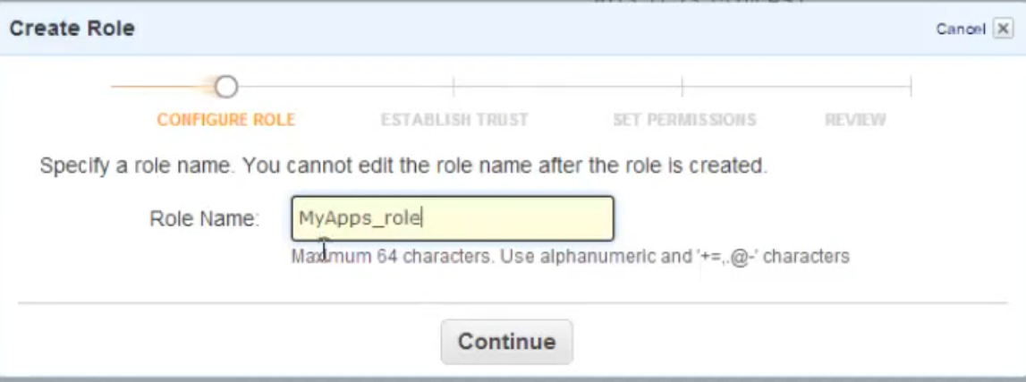

3. 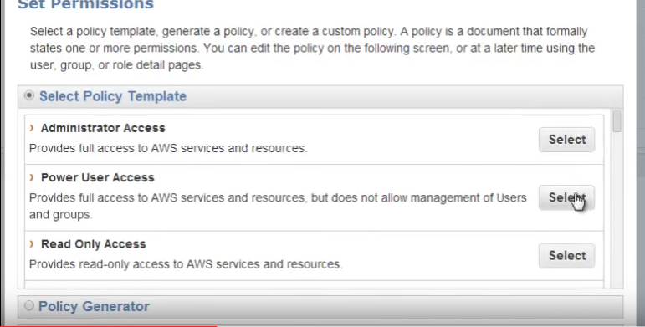

On the Attach Policy page, select an AWS managed policy. For example, for Amazon EC2, one of the following AWS managed policies might meet your needs:

PowerUserAccessReadOnlyAccess

AmazonEC2FullAccess

AmazonEC2ReadOnlyAccess

4. TH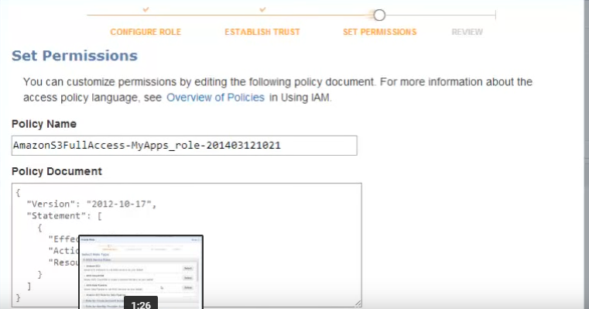

The policy can also be generated by AWS policy generator

5. Review the role information, edit the role as needed, and then choose Create Role.

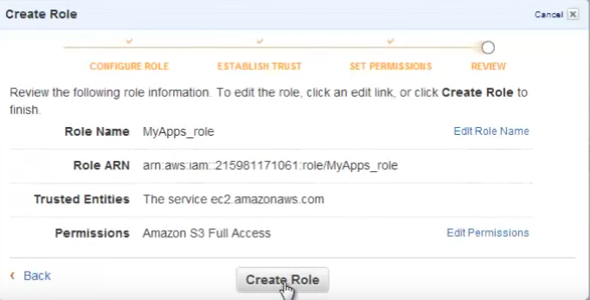

6. 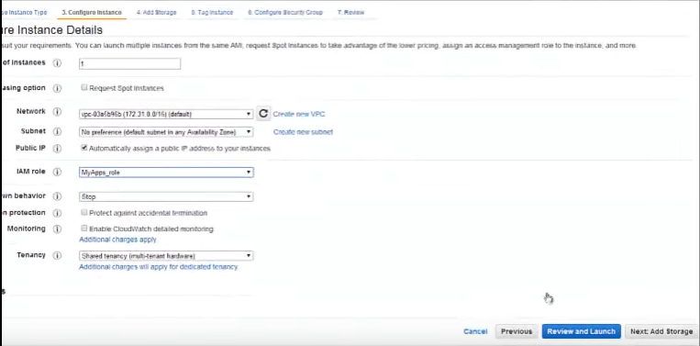

In the Instance Details select the Created IAM Role and Launch a Windows AMI

7.

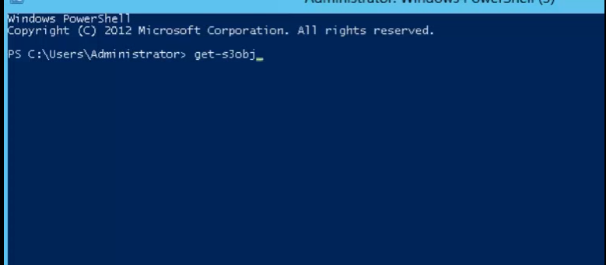

Go to POWER SHELL >get-s3object <bucket name> to access the created objects in the bucket